Kipp Gas Generator.

Gases on tap.
The Kipp generator was invented in 1844 by Petrus Jacobus Kipp and used throughout the rest of the 19th and the entire 20th centuries. Indeed, Kipp generators are still being used in some places. When qualitative analysis was taught to all students of chemistry, the Kipp generator was used to provide hydrogen sulfide for determination of specific metal ions.
Left: A Kipp 40-cm tall generator being filled with zinc chunks. Right: A line drawing showing the general design of a Kipp generator. The zinc goes in the gas reservoir and is prevented from falling into the lower base by the conical piece of glass with the small holes (the inner separator).
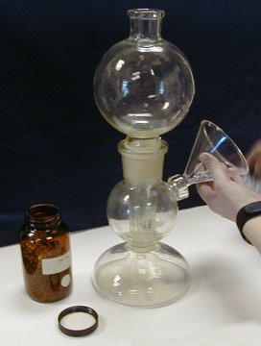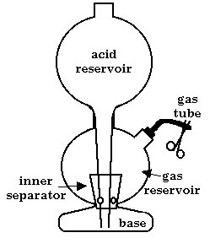
Here Kayla uses a glass stir rod to position the zinc evenly around the cone-shaped inner separator
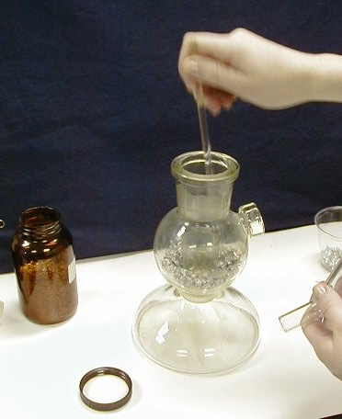
The acid reservoir will eventually contain the acid used in the reaction. Notice that the long glass tube passes through the center of the inner separator and will deliver the acid directly to the lower base chamber. (See line drawing above.)
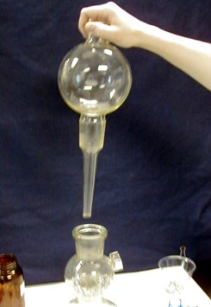
Another view of Kayla positioning the acid reservoir. At right, drawing shows the location of the zinc relative to the inner separator and acid reservoir.
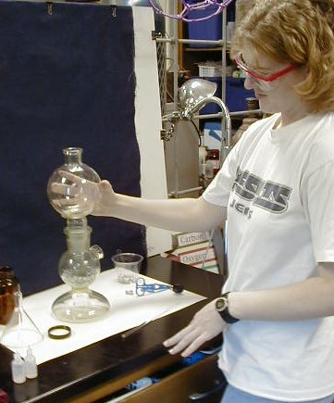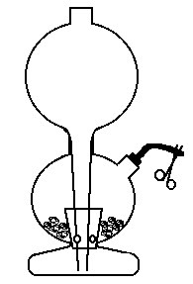
Next the 1 M HCl is added. The gas reservoir (the middle chamber) is a closed system and the air pressure prevents the acid from draining down into the base. At this point the acid and zinc have not come in contact.
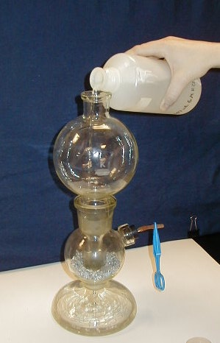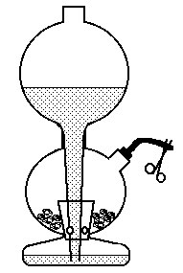
Kayla releases the hemostat and the air rushes out of the gas tube allowing the acid to drain from the upper (acid) reservoir to the base chamber. Things are getting exciting!
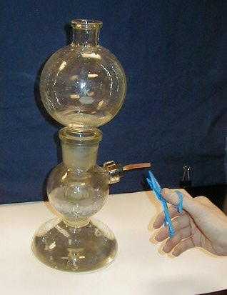
These two drawings explain the action! Because the hemostat is removed, gas is jetting out of the gas tube. This allows the acid to drain from the acid reservoir to the base chamber. The acid level rises in the base chamber and (right) eventually starts to pass through the holes in the inner separator where it reacts with the zinc. Now hydrogen is being generated and will start issuing from the gas tube. (The gas reservoir initially contained air which is quickly displaced by the hydrogen.)
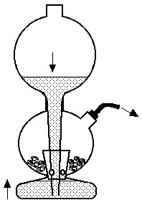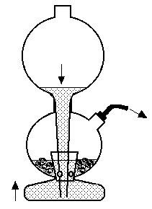
Hydrogen displaces water in a jumbo test tube (300 mL) within seconds!
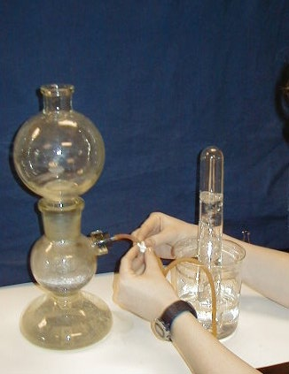
By clamping the gas tube, (1) delivery of hydrogen stops, (2) the pressure inside the gas reservoir builds up which (3) forces the acid back out of the gas reservoir and into the base chamber and (4) back up into the upper acid reservoir! When the acid and zinc are no longer in contact, the generation of hydrogen ceases.... until someone opens the gas tube again! Hydrogen is 'on tap.'
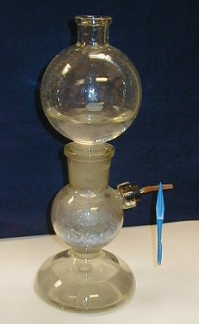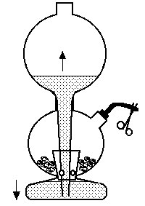
Here Kayla and Scot fill one of our 60-mL syringes -- old meets new!
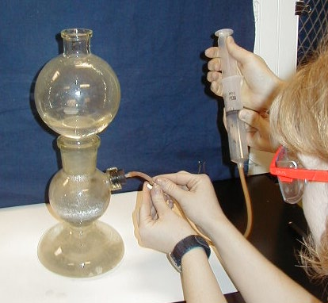
Here is a larger (62 cm) Kipp generator which arrived at Creighton on Halloween (which explains why Kayla looks the way she does, but does not explain Mattson's appearance!) We have not fired the big one up yet! Left is Professor Bruce Mattson in his lab and right is Kayla Pound, a Creighton chemistry major. Her research on generating gases in a microwave oven is published in Chem13 News and available at this site.
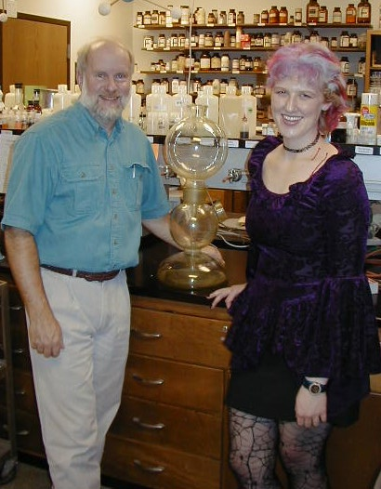
Special thanks! Bruce Mattson would like to thank Ron Perkins of Educational Innovations for his kind gift of the two Kipps generators. Be sure to shop his store (Educational Innovations) for all of your science needs!

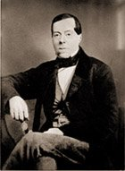  Petrus Jacobus Kipp  Born 5 March 1808 in Utrecht  Died in Delft, Netherlands 3 February 1864 | Petrus Jacobus Kipp was a Dutch pharmicist. He and wife (H)anna Petronella Regina Heijligers had 10 children. Kipp founded Kipp and Zonen, B.V. (literally Kipp and Sons) in 1830 and was in the business of trading (buying and selling) fine instruments. In 1844, Kipp invented his famous gas generator . The original one was 62 cm high -- the same as the one pictured above.  The company was acquired in 1996 by SciTec Instruments Inc. of Saskatoon, Saskatchewan, Canada. They subsequently changed their name to Kipp and Zonen, Inc. Their website features a nice historical tribute to the 170-year old company.
Additional sources of historical information on Kipp gas generators exist. A few include:
1. Humboldt State University has a virtual museum that includes quite a lot of interesting information about Kipp generators and similar devices.
2. Dr. Ernst Homburg has kindly given us permission to provide a copy of his article which includes a biographical information on P. J. Kipp as well as some history of the Kipp generator and his company. The actual article will be published in the "RSC Historical Group Newsletter" (Spring 2001). Readers of the actual article can also find an illustration of the original Kipp apparatus.
With best regards,
Ernst Homburg
3. An excellent article by E.E. Aynsley & W. A. Campbell is available in the Journal Chemical Education 35 (1958) 347-49. This article includes a number of interesting line drawings including one for the original model of the Kipp generator.
4. The following paper (in French) has reproductions of early plates of consecutive versions of Kipp's apparatus from the 1840's: "H. Snelders, "Le pharmacien P. J. Kipp (1808-1864) et son appareil," Revue d'Histoire de la Pharmacie, vol. XXI (1972) pp. 3-12.
Mattson wishes to thank William Brock, Ernst Homburg, Robert Lancashire, and Peter Morris for providing me with invaluable information of the histroy of the Kipp generator

